SOCIAL BUSINESS MAPPING QUESTIONNAIRE
(For National Societies)
WHO ARE WE ?
The Social Entrepreneurship informal working group meets every 2 weeks to work on the priorities set by the 3rd Social Entrepreneurship Meet-up in Mombasa, Kenya in July 2025. It is represented by :
- The Kenya Red Cross Society
- The French Red Cross
- The Austrian Red Cross
- The Lebanese Red Cross
- The IFRC Secretariat

It is an informal and open group, that welcomes new members to discuss and/or contribute to the roadmap at any level of engagement. Want to join ? Contact mariealice.manderscheid@croix-rouge.fr
REMINDER OF THE OBJECTIVE
Through this collective exercise, the Social Entrepreneurship informal working group would like to build a shared understanding of SE (Social Entrepreneurship) in the RCRC Network by creating an extensive, living, structured document enabling a wide range of NS to present their intiatives clearly (using a common template).

This understanding should help identify what works, what doesn't, but also the common social problem, challenges and potential opportunities.
A QUICK REMINDER OF THE KEY DEFINITIONS
- Social entrepreneurship is a mindset. “Social entrepreneurship describes an entrepreneurial action which aims to solve social or environmental challenges while pursuing financial sustainability.” (Source, How to Foster Resilience through Social
- Entrepreneurship, 2024). In other words, social entrepreneurship is a mindset
- Social business is an organisation: “An organisation that applies business strategies to address social or environmental issues, prioritising positive impact alongside financial sustainability. Profits are reinvested into the social impact project, and the goal is not necessarily profitability but rather creating significant social or environmental benefits. (Source, How to Foster Resilience through Social Entrepreneurship, 2024)
In addition, to further identify what kind of activities fall within Social Entrepreneurship, the working group has formalized the following matrix. We consider that social entrepreneurship activities can be of three kind :
- Business activities that fall within the “commercial zone” that do not have social impact as their core mission, but have an indirect impact on communities by sustaining core activities of National societies and branches. (Ex. Car rental businesses)
- Business activities that fall within the “livelihood zone” that do not have social impact as their core mission, but have a direct impact on the socio economic well-being of communities by increasing their resilience (Ex. Vulnerable communities formalizing businesses)
- Business activities that fall within the social business zone. These activities have social or environmental impact as their core mission, and manage to generate income This is end-goal of social entrepreneurship programs.
If our mapping is looking to map out all types of activities (1,2,3), as much as possible, on the long run we strive to bring all businesses in the social business zone (3), although we recognize this may not always be easy or possible. Some Social Entrepreneuship programs, such as REDPreneur or WSEI, were designed for this.

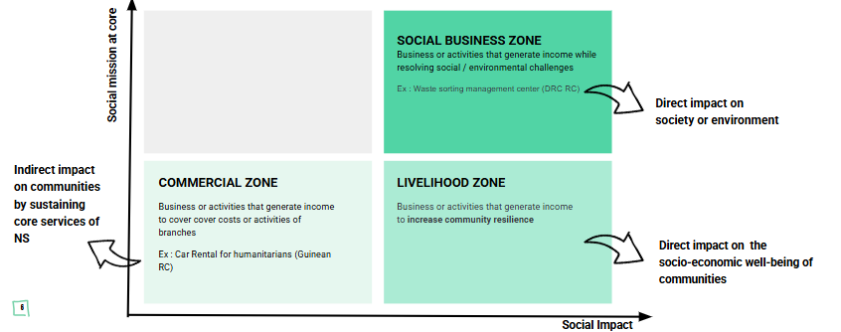
INTRODUCTORY QUESTIONS :
- Does your NS run a Social Entrepreneurship Program? (Yes / No / If yes, name of Program)
- Are you aware of a business activity launched or run by your NS? (Yes / No / If no, but are interested in launching one please take contact with us)
- Is your business part of a Social Entrepreneurship Program ? (Yes / No / If yes, which one ?)

PART 1 — IDENTITY & STRUCTURE
1. National Society (Mandatory)
[Open field]
2. Name of the Business Activity (Mandatory)
[Open field]
3. In regard to the matrix, in which quadrant (1, 2 or 3) does your activity fall ? (Mandatory)
☐ 1. Commercial Zone
☐ 2. Livelihood Zone
☐ 3. Social Business Zone
4. Year of Establishment of the Business activity (Mandatory)
[Dropdown by year]
5. Level of operation (Mandatory)
☐ HQ-level initiative
☐ Branch-level initiative
☐ Both HQ and branches
6. Hosting unit within the National Society (Innovation Unit, NSD, Livelihood, etc) (Mandatory)
[Open field]
7. Is your business activity part of a broader Social Entrepreneurship Program? (REDPreneur, WSEI, etc.) (Mandatory)
[Open field]
8. Legal status of the activity (Mandatory)
☐ Not formally registered yet
☐ Registered as a department of the National Society
☐ Registered as a separate legal entity
9 If separate entity, legal form: (optional, if answered “registered as a separate legal entity for question 8 )
☐ Non-profit organization
☐ Cooperative
☐ Limited liability company (LLC)
☐ Other: ______
10. Country(ies) of operation (Mandatory)
[Open field / multiple selection]
11. Key contact person (name, title, email) (Mandatory)
[Open field]

PART 2 — VALUE PROPOSITION & IMPACT
12. In one sentence, describe your main business activity (Mandatory)
[Short open field]
13. What social / humanitarian problem are you addressing? (Mandatory)
[Short open field]
14. Main sector of operation (Mandatory)
☐ Livelihoods/Empowerment
☐ Health
☐ WASH
☐ Climate & Environment
☐ Logistics
☐ Training
☐ Other: ______

PART 3 — USERS & BENEFICIARIES
15. Business model type (Mandatory)
☐ B2C (selling directly to individuals)
☐ B2B (selling to companies)
☐ B2G (selling to government)
☐ Internal (selling to the National Society)
16. Describe your main paying customers? (Mandatory)
[Short open field]
17. Do you have non-paying customers (beneficiaries)? If so describe (Optional)
[Short open field]
18. How to reach out to your paying customers? (Mandatory)
☐ Online channels (social media, website, platforms)
☐ Events and public outreach
☐ Direct sales / community outreach
☐ Partnerships (companies, NGOs, government)
☐ Other: ______

PART 4 — REVENUE STREAMS & BUSINESS MODEL
19. How is the social business currently funded? (Mandatory)
☐ Primarily grants
☐ Primarily revenue-generated
☐ Hybrid (grants + revenue)
☐ Still in pilot phase (not yet generating revenue)
20. Main revenue sources (select all that apply) (Mandatory)
☐ Product sales
☐ Service contracts
☐ Subscription model
☐ Licensing / franchising
☐ Membership fees
☐ Consulting services
☐ Commission-based income
☐ Public procurement contracts
☐ Other: ______
21. What is your annual revenue range? (Mandatory)
[Short open field]
22. Financial situation (Mandatory)
☐ Operating at a loss
☐ Break-even
☐ Generating surplus reinvested into mission
☐ Generating surplus redistributed to National Society core costs
23. If your activity is generating surplus, what percentage is invested into the social mission versus National society core costs? (optional)
[Short open field]

PART 5 — MATURITY & CAPACITY
24. Stage of development (Mandatory)
☐ Pilot stage
☐ Early growth
☐ Scaling nationally
☐ Scaling internationally
25. Number of paid staff (Mandatory)
☐ 0–2
☐ 3–10
☐ 11–25
☐ 25+
26. Number of customers reached annually (Mandatory)
[Short open field]
27. Has the team received any specific entrepreneurship or business development training? If so, please mention from where (optional)
[Short open field]
28. What are your main current needs? (select up to 3) (Mandatory)
(Areas where venture needs support)
☐ Access to funding / investment
☐ Business development support
☐ Impact measurement tools
☐ Legal advice
☐ Marketing & branding
☐ Market access / partnerships
☐ Digital tools
☐ HR / recruitment
☐ R&D / product development
☐ Other: ______

29. What are your main strengths? (select up to 3) (Mandatory)
☐ Strong mission alignment
☐ Strong volunteer base
☐ Strong local legitimacy
☐ Solid partnerships
☐ Financial sustainability
☐ Innovation capacity
☐ Strong leadership
☐ Strong brand recognition
☐ Government relationships
☐ Scalable model
☐ Access to RCRC network / partners
☐ Other: ______
30. Any additional documents? (Optional)
☐ Business Plan
☐ Annual reports
☐ Photos/Media
☐ Impact report
Are you open to sharing the content provided in this questionnaire with the RCRC Network? (Mandatory)
☐ Yes
☐ No

